**Tech Mahindra Week 4 Task - Website Documentation**

**by Jeffery Matthew**

This document provides an overview of the website "InnovateX" as observed from the given screenshots. The purpose is to outline the structure, content, and intended functionality of the various pages of the website.

**Home Page**

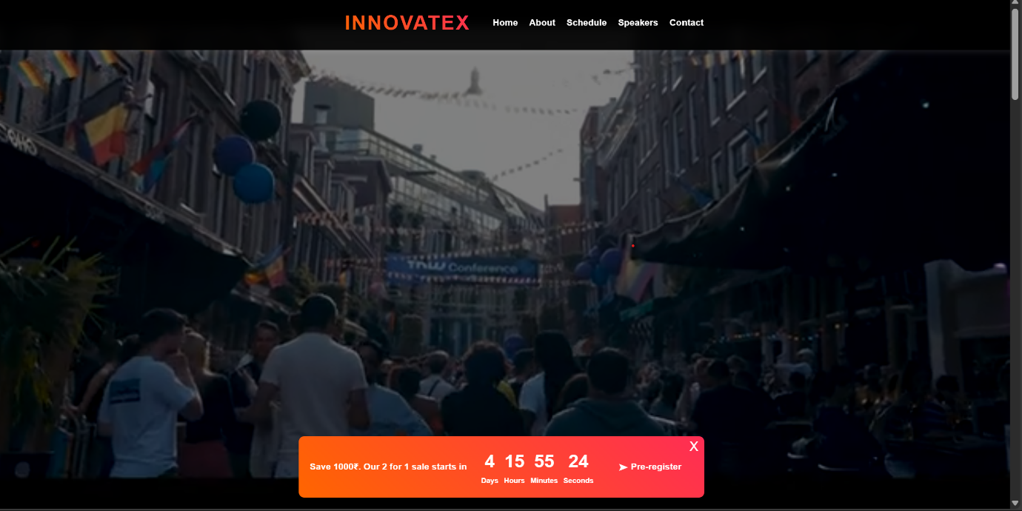

The homepage introduces "InnovateX: Shaping the Future of Technology," an event focused on AI, cybersecurity, cloud computing, and other emerging tech trends.

Key Features:

* Event Description: A brief overview of InnovateX and its mission.
* Call-to-Action Buttons:
  + "Register Now" (Likely redirects to a registration page)
  + "View Schedule" (Probably leads to the event schedule)
* Dark Theme with Gradient Accents: Enhances readability and modern UI aesthetics

**Speakers Page**

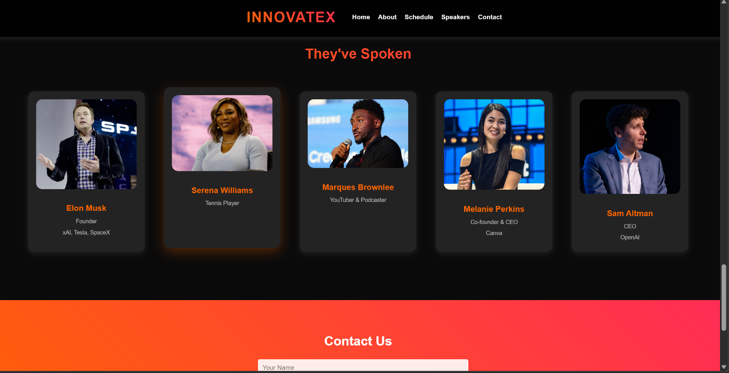

This section highlights notable speakers who have attended InnovateX.

Key Features:

* Profiles of Industry Leaders:
  + Elon Musk (Founder, xAI, Tesla, SpaceX)
  + Serena Williams (Tennis Player)
  + Marques Brownlee (YouTuber & Podcaster)
  + Melanie Perkins (Co-founder & CEO, Canva)
  + Sam Altman (CEO, OpenAI)
* Professional Roles Displayed: Each speaker’s role is mentioned, emphasizing their contributions.
* Consistent Card Layout: Enhances visual appeal and readability.

**Event Page**

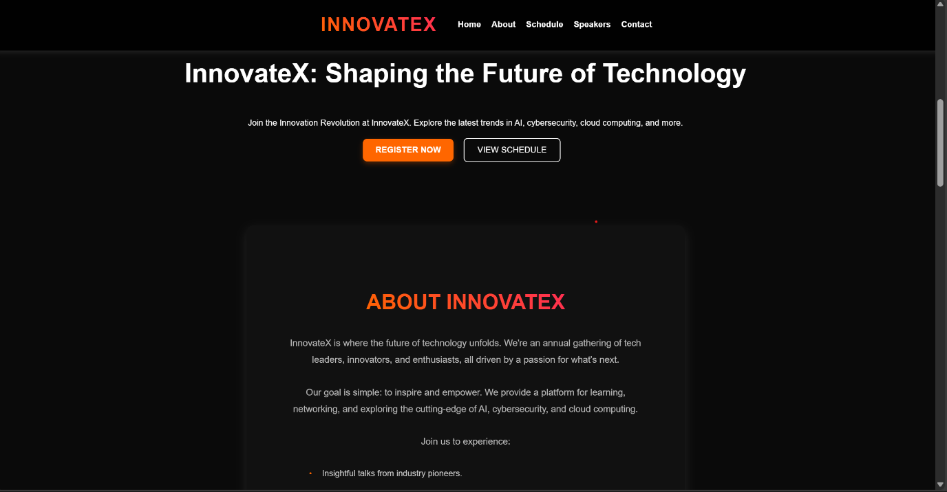

This section likely provides details about the upcoming InnovateX event, offering pre-registration options.

Key Features:

* Event Scene Image: Shows a vibrant crowd, possibly indicating an outdoor or hybrid event setup.
* Countdown Timer: Displays time left for a special registration offer.
* Pre-Registration Button: Encourages early sign-ups with a limited-time discount.
* Engaging UI: Bright colors and dynamic elements to capture attention.

**Conclusion**

The InnovateX website presents an engaging and visually appealing interface, effectively promoting the event. The homepage offers an introduction, the speakers page highlights key guests, and the event page encourages participation through countdown-based offers. The website aims to attract tech enthusiasts and industry leaders to a cutting-edge technology conference.